ARCHITECTURE TO MAKE PEOPLE MATTER: LESSONS FROM THE BERKELEY PRIZE
By Benjamin Clavan, Ph.D., Architect
TRANSCRIPT OF A VIRTUAL TALK TO THE SCHOOL OF PLANNING AND ARCHITECTURE, BHOPAL, INDIA
16 JULY 2020
(Edited for reading, with supplementary material added.)
----------------------------------------------------------------

GOOD AFTERNOON.
FOR THE PAST FEW WEEKS I HAVE BEEN TELLING MY COLLEAGUES THAT I WOULD BE GIVING A TALK IN BHOPAL, INDIA. SINCE FOR THE MOMENT I AM IN SPAIN, THE REACTION HAS FIRST BEEN SURPRISE, THEN A PAUSE, THEN I ADD THE WORD VIRTUAL AND EVERYONE IMMEDIATELY NODS AND BREATHES A SMALL SIGH OF RELIEF. THE VERY THOUGHT OF SUCH TRAVEL ANYWHERE IN THESE TIMES RAISES CONCERNS.
I WOULD MUCH RATHER BE IN FRONT OF YOU TODAY IN 3-DIMENSIONS, BUT CLEARLY THERE IS, FOR THE MOMENT AT LEAST, THIS NEW VIRTUAL NORMAL.
--------------------------

IN HER INITIAL OUTREACH FOR THIS TALK, PROFESSOR RACHNA KHARE TOLD ME THAT,
SPA BHOPAL IS STARTING AN ONLINE LECTURE SERIES TO INSPIRE OUR ARCHITECTURE STUDENTS AND YOUNG PROFESSIONALS IN THE TIME OF THIS PANDEMIC. .THE SPEAKERS WOULD SHARE THEIR PROFESSIONAL JOURNEY - THE CHALLENGES THEY EXPERIENCED THROUGHOUT THEIR CAREER, AND HOW THEY OVERCAME THOSE CHALLENGES. NOBODY KNOWS HOW THE LIFE WOULD BE POST-COVID, BUT OUR AIM IS TO KEEP OUR YOUNG PROFESSIONALS INSPIRED AND TAKE THESE CHANGES AS PART OF LIFE.
BECAUSE MUCH OF MY PROFESSIONAL LIFE AS A PRACTICING ARCHITECT HAS BEEN INTERTWINED WITH MY ACADEMIC INTEREST IN THE SOCIAL ART OF ARCHITECTURE AND IN TURN, WITH MY ASSOCIATED WORK ON THE INTERNATIONAL BERKELEY UNDERGRADUATE PRIZE FOR ARCHITECTURAL DESIGN EXCELLENCE, THIS TALK IS REALLY AN AMALGAM OF ALL THREE SUBJECTS: WORKING AS AN ARCHITECT; APPLYING SOCIAL FACTORS TO DESIGN; AND THE BERKELEY PRIZE.
-------------------------

I HAVE VISITED INDIA TWICE. ONCE, A NUMBER OF YEARS AGO TO CALCUTTA AND THE SURROUNDING AREA; AND IN 2009 TO DELHI, AGRA AND, OF COURSE, CHANDIGARH.
I SAY OF COURSE BECAUSE CHANDIGARH WAS ONE OF MY GENERATION’S ARCHITECTURAL SUCCESS STORIES. A NEW CITY BASED ON NEW PLANNING PRINCIPALS FOR A NEW WORLD, COMPLETE WITH A NEW ARCHITECTURE TO MATCH ALL OF THIS OTHER NEWNESS.

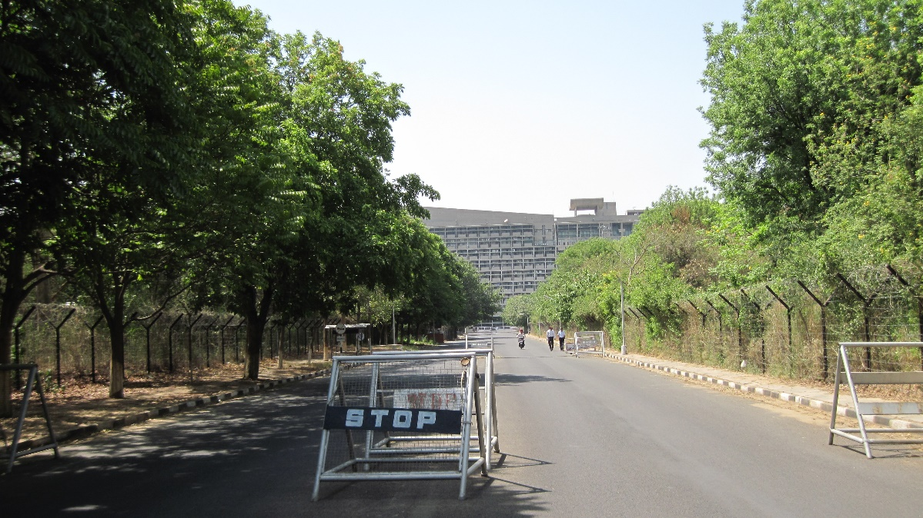
(ILLUSTRATION #1: Chandigarh Government Center)

IT WAS ONLY LATER THAT CRITICAL THINKERS BEGAN TO DISASSEMBLE THIS FICTION AND TO RAISE QUESTIONS.
THE MOST POINTED CRITICISM WAS THAT LE CORBUSIER, THE GREAT FRENCH MODERNIST ARCHITECT WHO WAS AT THE FOREFRONT OF BRINGING THE INTERNATIONAL STYLE OF ARCHITECTURE TO THE WORLD, HAD DESIGNED A CITY EXPRESSLY FOR THE AUTOMOBILE, THE MAJORITY OF WHOSE POPULATION AT THE TIME COULD HARDLY AFFORD TO BUY A BICYCLE.
TODAY, A MUCH LARGER PERCENTAGE OF THE INDIAN POPULATION CAN WELL AFFORD AN AUTOMOBILE OR AT LEAST A MOTOR SCOOTER, BUT THE WORLD HAS MOVED ON.
THE WORLD’S CLIMATE AND SUSTAINABILITY ISSUES AND THE EFFECTS OF THE INTERNAL COMBUSTION ENGINE ON LOCAL POLLUTION ALL POINT TO A FUTURE IN WHICH THE NEED TO REDUCE THE USE OF AUTOMOBILE IS PARAMOUNT.

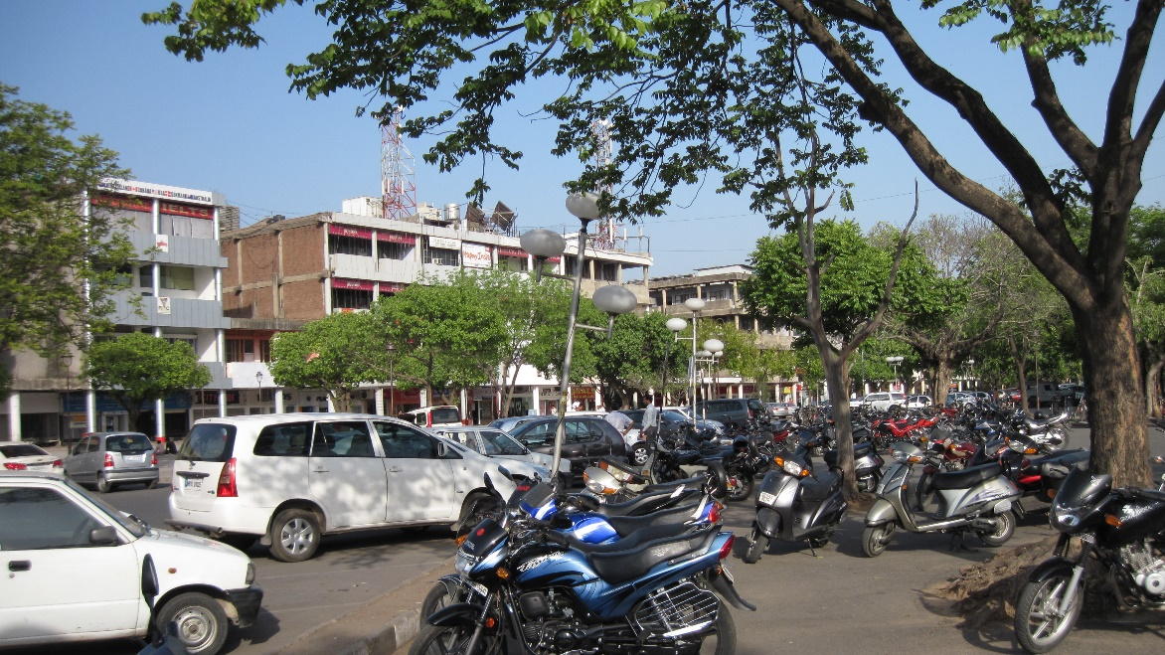
(ILLUSTRATION #2: Chandigarh Town Center)

ESCAPING THE CONGESTED URBAN CORE TO LIVE IN A BEDROOM SUBURB HAS IN THE LATTER HALF OF THE 20TH CENTURY BEEN SEEN IN MANY PARTS OF THE WORLD AS A REWARD FOR MONETARY SUCCESS. AT THE SAME TIME, THE NEGATIVE EFFECTS OF SUCH PLANNING ON THE DEVELOPMENT OF RICHLY-TEXTURED COMMUNITIES, NOT TO MENTION THE SUBSEQUENT DIMINUTION OF URBAN LIFE ITSELF RAISES QUESTIONS ABOUT THE ENTIRE CONCEPT OF A PLACE LIKE CHANDIGARH.
CHANDIGARH IS, TO BE BLUNT, A CASE STUDY IN NOT APPLYING THE LESSONS OF THE SOCIAL ART OF ARCHITECTURE.
------------------
BEFORE I GO FURTHER, HOWEVER, WE NEED TO AGREE TO THREE GROUND RULES THAT PROVIDE A CONTEXT FOR MY REMARKS:
PROVISO #1: SOCIAL AND CULTURAL DIFFERENCES
I AM CLEARLY FROM THE OTHER SIDE OF THE WORLD. I HAVE LED A PRIVILEGED LIFE, RAISED IN THE UNITED STATES IN A MILIEU OF WHITE, UPPER MIDDLE-CLASS PROFESSIONALS, ACADEMICS, BUSINESS OWNERS, AND ARTISTS – WELL-EDUCATED LEADERS IN THEIR CHOSEN FIELDS.
AS A RESULT OF THIS LIFE OF RELATIVE EASE, GOING TO THE BEST SCHOOLS, BEING ABLE TO CHOOSE A CAREER PATH, MY BECOMING AN ARCHITECT AND OBTAINING MY PH.D. - WERE NOT PRIVILEGES AS SUCH, IT WAS WHAT WAS EXPECTED OF ME.
MY EXPERIENCE IS NOT TYPICAL IN THE UNITED STATES, NOR WOULD I ASSUME IN INDIA. MORE IMPORTANTLY, THE INDIAN EXPERIENCE, AND PERHAPS YOUR PERSONAL EXPERIENCES - REGARDLESS OF YOUR BACKGROUND - ARE PROBABLY MUCH DIFFERENT THAN MINE.
SO, WE ALL NEED TO REALIZE THAT THE DIFFERENCES BETWEEN PEOPLE ARE IN MANY CASES DIFFICULT TO UNDERSTAND, LET ALONE RESPOND TO IN ANY FORMULAIC WAY.
AS ARCHITECTS, WE CAN TRY TO DESIGN FOR EVERYONE, BUT AT THE SAME TIME WE NEED TO ACCEPT THE FACT THAT, YES, THERE ARE BASIC SIMILARITIES, BUT THERE IS ALSO A WHOLE HOST OF SOCIAL AND CULTURAL DIFFERENCES THAT NEED TO BE DETAILED AND ADDRESSED.
------------------
PROVISO #2: THE OTHER
A MORE IMPORTANT ISSUE IN MY BIOGRAPHY, HOWEVER, WAS THAT MY FAMILY’S RELIGION WAS JUDAISM. THIS, IN ITSELF, EVEN IN THE UNITED STATES SET US APART. IT MADE US DIFFERENT. AT TIMES, THIS MEANT BLATANT DISCRIMINATION AGAINST WHERE WE COULD COMFORTABLY LIVE; AT OTHER TIMES, MORE SUBTLE BIAS – NOT BEING ACCEPTED IN CERTAIN BUSINESS, SOCIAL, AND EVEN ACADEMIC SETTINGS.
SO, WE NEED TO AGREE TO ANOTHER SOCIAL CONSTRUCT – THAT OF THE OTHER. THIS CAN BE IDENTIFIED NOT ONLY WITH ONE’S RELIGION, RACE, ETHNICITY, SEXUAL PREFERENCE, PHYSICAL OR MENTAL DISABILITIES – BUT ANYTHING THAT SEEMS OUTSIDE OF THE SUPPOSED NORM.
WHAT IS THE MOST INTERESTING ABOUT THIS TRUISM IS THAT IF WE LOOK HARD ENOUGH, WE ALL ARE – AT ONE POINT OR ANOTHER – IN OUR LIVES, THE OTHER.
LET ME GIVE YOU SOME EXAMPLES CLOSE TO HOME, BUT MORE OR LESS TYPICAL TO ONE EXTENT OR ANOTHER AROUND THE WORLD:
IN INDIA THE DISABLED POPULATION NUMBERS ANYWHERE FROM 26 MILLION TO 70 MILLION OR HIGHER, INCLUDING THOSE WITH MOVEMENT DISABILITIES, HEARING IMPAIRMENTS, VISUAL IMPAIRMENTS, SPEECH IMPAIRMENTS, MENTAL IMPAIRMENTS. THIS IS FROM GOOGLE. AND THESE NUMBER DO NOT EVEN INCLUDE THOSE WHO ARE TEMPORARILY DISABLED – FOR INSTANCE, BREAKING A LEG AND HAVING TO HOBBLE AROUND ON CRUTCHES FOR SIX WEEKS.
IN INDIA IT IS ESTIMATED THAT HOMOSEXUALS MAKE UP 2-13% OF THE TOTAL POPULATION. THIS ALSO IS FROM GOOGLE. GIVEN THAT THIS TALK IS BEING GIVEN IN A DESIGN SCHOOL WHERE SEXUAL ROLES SEEM TO BE MORE FLUID THAN IN THE REST OF THE POPULATION, THE PERCENTAGE IS PROBABLY ON THE HIGHER END. SO, MAYBE 15-20 OF YOU LISTENING TO ME TODAY LEAD OR WILL LEAD AN ALTERNATE BEHAVIORAL LIFESTYLE AND PROBABLY A MATCHING ALTERNATE PHYSICAL LIFESTYLE THROUGHOUT YOUR LIFE.
IN INDIA, THERE ARE TENS OF MILLIONS OF PEOPLE WHO ARE HOMELESS, THAT IS, LIVING WITHOUT SHELTER. YOU DO NOT NEED GOOGLE TO CONFIRM THIS. UNFORTUNATELY, ALL OF THEM ARE TYPICALLY THOUGHT OF AS OF LESSER IMPORTANCE AND CLEARLY, THE OTHER.
FOR ALL OF THESE PEOPLE, THEIR LIVES, THEIR NEEDS ARE MUCH DIFFERENT THAN YOURS OR MINE.
OH, WAIT A MOMENT, THEY ARE US…
A WORLD DESIGNED FOR THE 100% SIMILAR – AND SUPPOSEDLY PERFECT - HUMAN SPECIMEN IS A CONCEIT. LIFE SIMPLY DOES NOT WORK THAT WAY. ARCHITECTURE AND PLANNING CANNOT EITHER.
-------------
AND FINALLY, PROVISO #3: COMPASSION
FINALLY, COUPLED WITH MY UPBRINGING’S DEMAND TO ACHIEVE, WAS THE EXPECTATION THAT I GIVE BACK TO THE WORLD – THAT IN WHATEVER WAY SATISFIED ME MOST, I NEEDED TO DO GOOD.
I DO NOT KNOW ENOUGH ABOUT THE INDIAN CULTURE TO KNOW WHETHER THIS PRESSURE OF PUBLIC SERVICE IS ALSO FELT BY MANY OF YOU. AS WESTERNERS, OUR PICTURE OF MODERN INDIA IS OF A TRADITIONAL AND VERY LIMITED PRIVILEGED CLASS; A NEW AND GROWING, BUT NOT YET SECURE MIDDLE CLASS; AND A VAST POPULATION STILL STRUGGLING JUST TO SURVIVE.
THIS DYNAMIC DOES NOT READILY POINT TO A SOCIETY OF (EVEN) PROFESSIONALS FOR WHOM DOING GOOD IS AMONG ITS PRIMARY AND VISIBLE GOALS. I COULD BE WRONG.
SO, THIRD, WE ALSO NEED TO AGREE THAT EVERYTHING I TALK ABOUT TODAY ARE EMPTY WORDS UNLESS THERE IS A COMMITMENT TO IMPROVE THE STATUS QUO AND TO ACHIEVE BY MAKING OTHER PEOPLE’S LIVES BETTER.
AS ARCHITECTS AND PLANNERS FROM ANY COUNTRY, THIS PRESSURE TO DO GOOD IS THE ONLY CRITERIA ON WHICH A SOCIAL ART OF ARCHITECTURE, IF IT HAS ANY CHANCE OF BECOMING A REALITY, CAN BE BASED.
SO, AS WE CONTINUE, KEEP THESE THREE PROVISOS IN MIND – THEY ARE THE OVER-RIDING CONTEXT FOR WHAT I HAVE TO SAY.

---------------------
MY GOAL AS A YOUNG ARCHITECT WAS TO BECOME THE NEXT FRANK LLOYD WRIGHT.

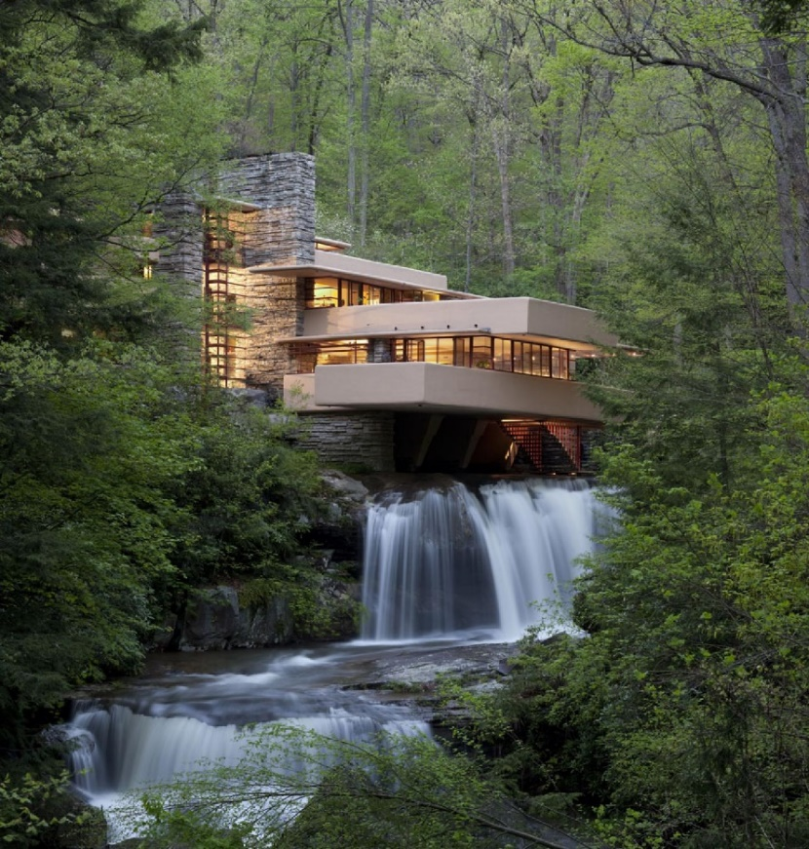
(ILLUSTRATION #3: Frank Lloyd Wright’s Fallingwater, A World Heritage site. Photograph by others.)

I AM NOT SURE, BUT PERHAPS CHARLES CORREA or B.V. DOSHI IS THE EQUIVALENT IN INDIA? HOPEFULLY YOU UNDERSTAND WHAT I AM GETTING AT.
I HAD THE PREPARATION, THE CREATIVITY, THE DISCIPLINE, AND I BELIEVE, THE CONTACTS TO MAKE THIS ASPIRATION SUCCEED.
IN ANY CASE, IT DID NOT. AT LEAST NOT TO THE DEGREE I HAD IMAGINED.
PART OF THE REASON WAS THAT, FORTUNATELY FOR ME, I DO NOT HAVE THE ASTOUNDING EGO, BORDERING ON MEGALOMANIA THAT WRIGHT HAD.
AND, DESPITE WRIGHT’S ROLE IN CREATING A QUINTESSENTIAL (BUT HIGHLY IDIOSYNCRATIC) AMERICAN ARCHITECTURAL STYLE, IT TURNED OUT THAT, IN THE END, CREATING MY OWN STYLE DID NOT REALLY INTEREST ME.
MORE IMPORTANTLY, AS MY CAREER ADVANCED, THIS ORIGINAL GOAL BECAME LESS AND LESS IMPORTANT.
MY YOUTHFUL FANTASY HAS BEEN REPLACED BY INCREDIBLY SATISFYING INTELLECTUAL AND PRACTICAL ACHIEVEMENTS I WOULD HAVE NEVER IMAGINED.
-----------------
MY OWN ARCHITECTURE IS SUMMED UP BY MY WEBSITE INTRODUCTION:

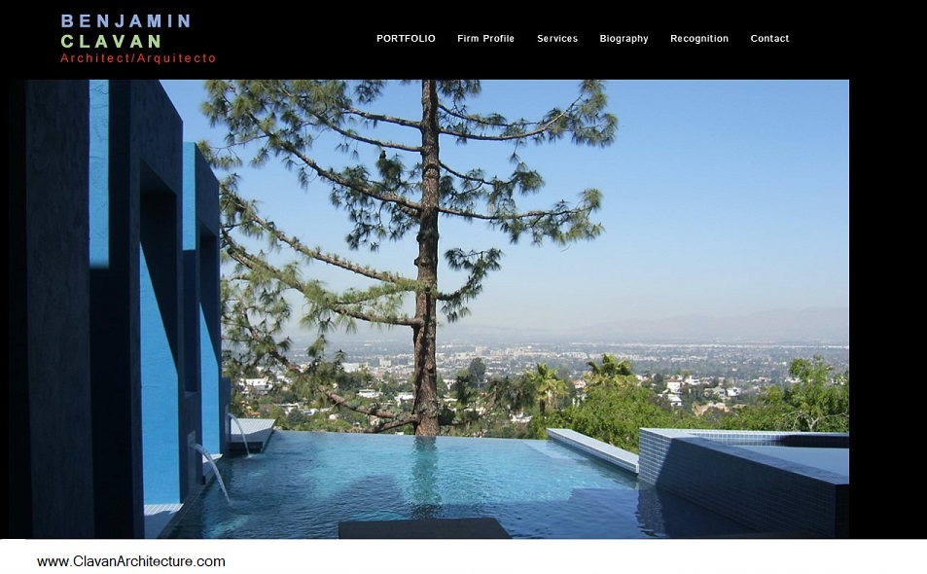
(ILLUSTRATION #4: A project photo on the homepage.)

“WE ARE A CLASSIC ATELIER DESIGN FIRM WITH OVER THIRTY-FIVE YEARS OF ON-THE-GROUND AND ADVANCED RESEARCH EXPERIENCE PROVIDING HIGHLY PERSONALIZED SERVICES FOR A WIDE RANGE OF SELECT RESIDENTIAL, COMMERCIAL, LANDSCAPE, AND INTERIORS PROJECTS.”
WHAT THIS CREED LEADS TO IS SEEKING OUT A WIDE VARIETY OF DESIGN PROJECTS WHERE THE POSSIBILITY AND PROMISE OF ONE-ON-ONE DIALOGUE WITH THE CLIENT OR CLIENTS TAKES PLACE. THESE HAVE NOT NECESSARILY BEEN “SOCIALLY CONSCIOUS” PROJECTS AS SUCH, NOR NECESSARILY COMMUNITY-ORIENTED PROJECTS.
THEY ARE, HOWEVER, SOCIALLY AWARE PROJECTS IN THAT THE OWNER AND I TRY TO FIGURE OUT WHAT IS BEST FOR THEM AND THEIR LIFESTYLE OR THEIR WORK – NOT A PRECONCEIVED ARCHITECTURAL MEME SUPPOSEDLY APPLICABLE TO ANY AND ALL DESIGN SITUATIONS.
IF YOU GO TO MY WEBSITE, YOU WILL SEE THAT I LIKE TO USE COLOR IN MY DESIGNS. I ONLY MENTION THIS BECAUSE, WELL, FIRST IT MAKES ME AND MY CLIENTS HAPPY; BUT SECOND, BECAUSE IT LED TO ONE OF MY MORE INTERESTING SOCIAL DESIGNS.
A SINGLE WOMAN, A YOUNG STRUGGLING LAWYER, HAD RECENTLY BEEN ALMOST PERMANENTLY BLINDED IN A BOTCHED EYE OPERATION. SHE USED PART OF THE RESULTING AND RESTRICTED MALPRACTICE AWARD TO PURCHASE A SINGLE-STORY HOME IN WHICH SHE ASSUMED SHE WOULD SPEND THE REST OF HER LIFE.
SHE COULD STILL SEE SHAPES AND DIFFERENTIATE BETWEEN (BOLD) COLORS, BUT IN ALL OTHER WAYS HER NEW WORLD WAS AN ALMOST TOTAL BLUR. THE HOUSE ITSELF NEEDED TO BE RETROFITTED IN A NUMBER OF WAYS TO MAKE IT LIVABLE FOR HER. AS AN “ARCHITECT,” QUOTE, END-QUOTE, I WOULD HAVE LOVED TO START TEARING DOWN WALLS AND MAKING THE PLACE 100% ACCESSIBLE.
THERE WAS NO BUDGET FOR THIS, NOR DID SHE WANT HER ENVIRONMENT TO LOOK THAT DIFFERENT FROM THAT OF HER FORMER LIFE – THAT OF SUPPOSEDLY NORMAL PEOPLE.
ONE OF HER MAJOR ISSUES WAS THAT ALL THE WALLS WERE A DISCREET COLOR OF BEIGE WHICH FOR HER MEANT THERE WERE NO EDGES AND NO TOP OR BOTTOM. SHE COULD NOT EVEN TELL WHERE THE MAJORITY OR HER 8 FT. HIGH (2.43 METERS) CEILINGS BEGAN.
I REMEMBER FOLLOWING HER DOWN A HALLWAY. THE HALL TURNED 90 DEGREES TO THE LEFT AFTER ELEVEN STEPS. THIS TIME SHE WAS EITHER NERVOUS BECAUSE I WAS THERE OR HAD OTHER THINGS ON HER MIND, BUT SHE MIS-COUNTED AND LITERALLY WALKED INTO THE WALL AT THE END OF THE CORRIDOR. FORTUNATELY, SHE WAS NOT HURT. IN FACT, SHE TOLD ME THAT SHE HAD DONE THAT SAME THING SEVERAL TIMES BEFORE.
IT WAS A STAGGERING MOMENT FOR ME. WHAT COULD I DO TO INSURE THAT THIS WOULD NEVER, EVER HAPPEN AGAIN? IN THE END, I USED MY INTEREST IN COLOR AND HER CAPABILITY TO SEE BOLD COLORS TO LITERALLY SIGN THE WALLS.
ON THE CORRIDOR I PAINTED A SERIES OF LARGE COLORED BLOCKS THAT REDUCED HER COUNT FROM 11 TO 3 AND ANOTHER BLOCK OF COLOR AT THE TURN IN THE HALL TO FURTHER WARN HER THAT SHE HAD REACHED THE CORNER. WE PLACED A PAINTING SHE BOUGHT IN HER PREVIOUS FULLY SEEING LIFE – AND THAT SHE REMEMBERED FONDLY - ON THAT WALL TO FURTHER ACCENTUATE THE END OF THE CORRIDOR.

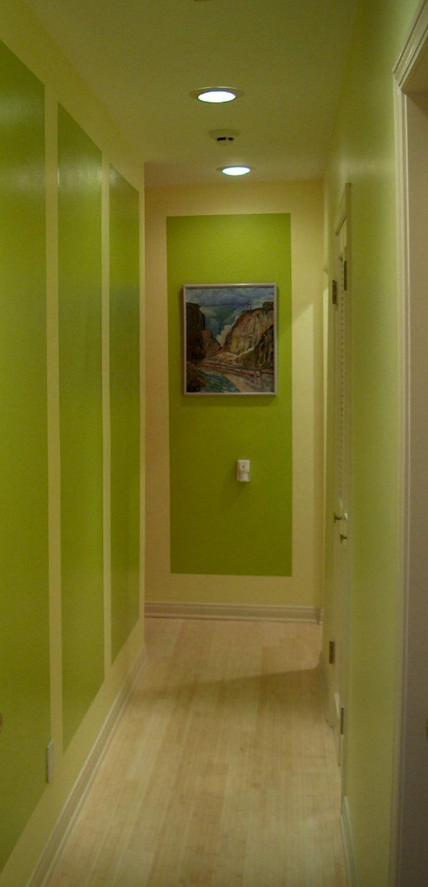
(ILLUSTRATION #5 – Residence hallway)

IN THE LIVING ROOM I PAINTED LARGE BOLD STRIPES ON THE VAULTED CEILING. SHE LATER TOLD ME THAT ALTHOUGH SHE HAD BEEN TOLD THERE WAS SUCH A CEILING IN THE ROOM, SHE HAD NEVER ACTUALLY BEEN ABLE TO SEE IT. WHEN I SHOWED HER THE RESULTS, SHE WAS SO OVERCOME WITH EMOTION, SHE HAD TO TURN AWAY FOR A MOMENT.

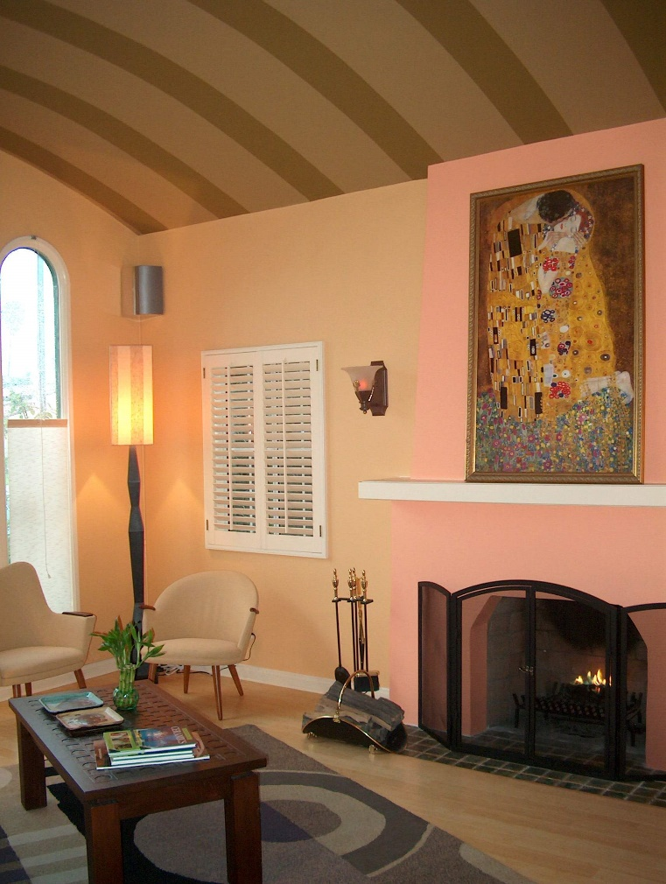
(ILLUSTRATION 6: Residence Living Room)

I ALSO SELECTED FURNITURE AND FLOOR COVERINGS WITH CONTRASTING COLORS AND PATTERNS SO THAT SHE COULD FIRST LOCATE THEM, BUT ALSO DIFFERENTIATE BETWEEN THE VARIOUS PIECES. IN THE NEW BATHROOM I AGAIN USED BOLD COLOR AND MANIPULATED TEXTURES TO HELP HER FIND HER WAY.
THIS WAS A PERSONAL SUCCESS FOR ME. IT DID NOT EARN ANY AWARDS. NOT VERY MUCH ARCHITECTURE WITH A CAPITAL “A” WAS INVOLVED. THE BUDGET AND MY FEE WAS FAIRLY LOW. THE PROJECT DID FEATURE FOR A FEW MINUTES ON A TELEVISION PROGRAM ABOUT DESIGNING FOR THE DISABLED, BUT THAT WAS SECONDARY.
----------------
IT WAS ALSO DEFINITELY NOT FRANK LLOYD WRIGHT – WHO INCIDENTALLY, IS QUOTED AS TELLING HIS STUDENTS:
“I TOOK THE HUMAN BEING, AT FIVE FEET EIGHT AND ONE-HALF INCHES TALL (1.74 METERS), LIKE MYSELF, AS THE HUMAN SCALE (FOR MY WORK). IF I HAD BEEN TALLER, THE SCALE MIGHT HAVE BEEN DIFFERENT.”

THINK ABOUT THAT.
FRIENDS CLAIM THAT WRIGHT WAS ACTUALLY SHORTER THAN HE CLAIMED AND POINT TO THE AVERAGE CEILING HEIGHT OF 6 FEET 4 INCHES (1.93 METERS) AT HIS HOME/STUDIO/SCHOOL - TALIESIN. HIS ENTRY DOORS WERE OFTEN 6 FEET 2 INCHES (1.88 METERS) HIGH REGARDLESS HOW TALL HIS CLIENTS. I WILL GIVE HIM A PASS ON THIS ONE, SINCE YOU COULD CLAIM THAT THE ENTRY ACTS AS A CONTRAST TO THE VOLUME OF THE STRUCTURE ITSELF, MAKING IT FEEL HIGHER.
[THE NOTION OF BINARY CONTRASTS OR BINARY OPPOSITIONS DEVELOPED BY CLAUDE LEVI STRAUSS, THE RENOWNED STRUCTURAL ANTHROPOLOGIST, HAS LESSONS FOR ARCHITECTS, BUT I DIGRESS…]
INTERESTINGLY, THE SMITHSONIAN MAGAZINE RECENTLY PUBLISHED AN ARTICLE ON WRIGHT’S LAURENT HOME IN ROCKFORD, ILLINOIS, THAT DESCRIBES THE PROJECT AS A “TRAILBLAZING EXAMPLE OF ACCESSIBLE DESIGN” FOR A DISABLED MAN AND HIS WIFE. FINISHED IN 1952 WHEN THE ARCHITECT WAS 85 YEARS OLD, THE HOUSE – ONE OF A HUNDREDS HE DESIGNED AND WERE BUILT – IS PERHAPS AN ADMISSION IN HIS LATER LIFE THAT THE NEEDS OF THOSE USING A STRUCTURE WERE AT LEAST AS IMPORTANT AS HIS OWN RIGID IDEOLOGIES.
IN ANY CASE, THE PROJECT OF MINE THAT I JUST DESCRIBED WAS BENJAMIN CLAVAN USING HIS OWN SKILLS AS A THINKING ARCHITECT AND HIS EMPATHY AS A FELLOW HUMAN TO MAKE ONE PERSON’S LIFE JUST A BIT MORE MANAGEABLE.
----------------
YOU MAY NOT DECIDE TO COMMIT YOUR LIFE’S WORK TO THE FURTHERING OF A PARTICULAR SOCIAL GOAL. NEVERTHELESS, AS A THOUGHTFUL PROFESSIONAL YOUR LIFE WILL NOT ONLY INCLUDE YOUR PAYING WORK, BUT MAY ALSO PROVIDE SERVICE TO THE COMMUNITY. THIS CAN OCCUR IN ANY VARIETY OF WAYS. I HAVE SERVED AND BEEN ELECTED TO VARIOUS CIVIC PLANNING COMMITTEES WHERE MY INPUT HAS, I HOPE, BENEFICIAL.
IT IS, HOWEVER, MY PART-TIME WORK FOR THE PAST 22 YEARS AS COORDINATOR AND WEBSITE CONTENT DEVELOPER FOR THE BERKELEY PRIZE –- THAT HAS BEEN THE MOST PERSONALLY REWARDING AND, I BELIEVE, THE MOST IMPORTANT IN FURTHERING WHAT IS, FOR ME, ESSENTIAL SERVICE TO THE COMMUNITY AND TO THE DISCIPLINE OF ARCHITECTURE AND PLANNING.
MOST OF YOU – AT LEAST HERE AT SPA BHOPAL - KNOW ABOUT THE PRIZE, SO I DO NOT NEED TO GO INTO DETAIL. WE SPONSOR A YEARLY ESSAY COMPETITION WITH A CHANGING TOPIC EACH YEAR FOCUSED ON THE SOCIAL ART OF ARCHITECTURE; PROVIDE TRAVEL FELLOWSHIPS FOR TRAVEL AND RESEARCH OUTSIDE OF THE STUDENT’S HOME COUNTRY TO EXPLORE THIS TOPIC FURTHER; AND HAVE DEVELOPED OTHER SHORTER-LIVED COMPETITIONS AND FELLOWSHIPS.
THE PRIZE WAS FOUNDED AND CONTINUES TO BE LED BY RAYMOND LIFCHEZ, PROFESSOR EMERITUS OF ARCHITECTURE AND CITY & REGIONAL PLANNING AT THE UNIVERSITY OF CALIFORNIA, BERKELEY’S COLLEGE OF ENVIRONMENTAL DESIGN (WHAT WE CALL THE CED), THROUGH A GENEROUS GIFT BY THE LATE JUDITH LEE STRONACH. THE PRIZE IS RUN COMPLETELY INDEPENDENTLY FROM THE CED, BUT IS FULLY ENDORSED BY THE DEPARTMENT OF ARCHITECTURE AT THE SCHOOL.

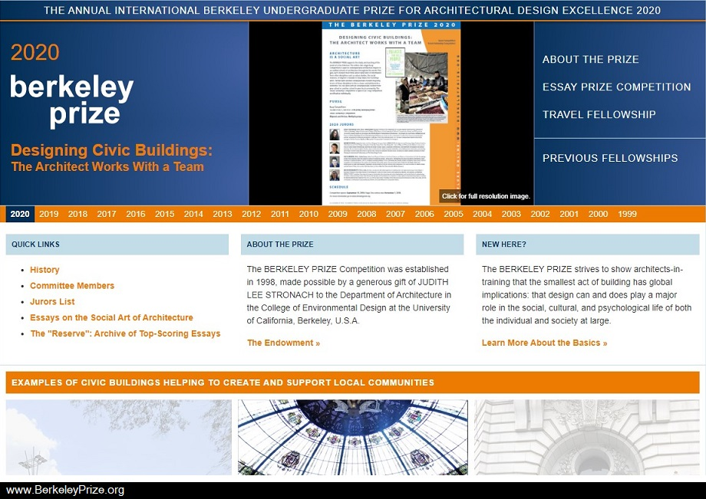
(ILLUSTRATION #7: The Prize homepage)

NOW ENTERING OR 23RD YEAR, THE BERKELEY PRIZE HAS SO FAR HAD 3100 UNDERGRADUATE ARCHITECTURE STUDENTS PARTICIPATE FROM 79 COUNTRIES. WE HAVE PRESENTED 151 AWARDS TO 171 INDIVIDUAL STUDENTS, SOME IN TEAMS OF TWO EACH. THE CROSS-FERTILIZATION OF IDEAS THROUGH WORKING TOGETHER IN TEAMS HAS ALWAYS BEEN ENCOURAGED.

YOUR CLASSMATES HAVE BEEN WINNERS OF OUR ESSAY COMPETITION. THE MOST RECENT, JUST THIS YEAR, WAS RHIDDHIT PAUL IN ARCHITECTURE AND ABHRADEEP CHAKRABORTY IN PLANNING FOR THEIR 1st PLACE ESSAY ENTITLED, “NESTS FOR A PHOENIX: BUILDING LIFE AFTER DEATH.”
YOUR MOST RECENT TRAVEL FELLOWSHIP WINNER WAS MS. JAHNAVI KANTAMNENI, WHO IN 2018 TRAVELED TO BATH, ENGLAND AND TO AMMAN, JORDAN TO PARTICIPATE IN THE “HEALTHY HOUSING FOR THE DISPLACED” PROJECT INITIATED BY THE UNIVERSITY OF BATH.
MUCH OF YOUR SCHOOL’S SUCCESS I AM SURE CAN BE TRACED TO SPA BHOPAL’S FOUNDING DIRECTOR AND PROFESSOR AJAY KHARE AND PROFESSOR RACHNA KHARE WHO IN 2013 WERE AWARDED A BERKELEY PRIZE TEACHING FELLOWSHIP FOR THEIR COURSE, “UNIVERSAL DESIGN FOR CULTURAL INTERFACE AT THE SCARED SITE OF UJJAIN IN MADHYA PRADESH, INDIA.”
YOU CAN SEE THEIR TEACHING FELLOWSHIP REPORT REGARDING THE PROJECT ON THE PRIZE WEBSITE AT: http://berkeleyprize.org/competition/teaching/2013/reports-from-fellows/ajay-khare-final-report

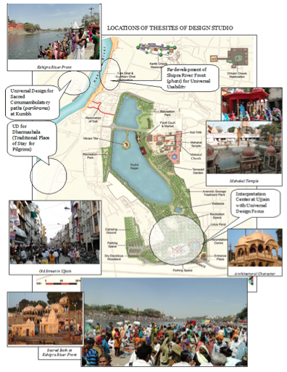
(ILLUSTRATION #8: UJJAIN Presentation Board)

AS A RESULT OF ALL OF THIS INTENSE INTEREST AND PARTICIPATION THE PRIZE HAS MORPHED INTO ONE OF THE WORLD’S LEADING ACADEMIC SHOWCASES FOR THE STUDY OF THE SOCIAL ART OF ARCHITECTURE. IN RECOGNITION OF THESE EFFORTS, THE PRIZE ITSELF WAS THE RECIPIENT OF A 2009 AMERICAN INSTITUTE OF ARCHITECTS COLLABORATIVE ACHIEVEMENT HONOR AWARD, AND A 2002 AMERICAN INSTITUTE OF ARCHITECTS EDUCATION HONOR AWARD.

THE BERKELEY PRIZE HAS ALSO GARNERED INTERNATIONAL ACCLAIM, NOT THE LEAST IS ITS COMPLETE EMBRACE OF DIGITAL TECHNOLOGY. IN PARTIAL RECOGNITION OF THIS OUTREACH, THE 2003 BERKELEY PRIZE COMPETITION WAS NAMED AS A SPECIAL EVENT OF "WORLD HERITAGE IN THE DIGITAL AGE," A VIRTUAL CONGRESS COMMEMORATING THE 30TH ANNIVERSARY OF THE UNESCO WORLD HERITAGE CONVENTION.

OVERALL, THE PRIZE IS AN AMBITIOUS PROJECT WITH MANY MOVING PARTS. IT REQUIRES EXTENSIVE PREPARATION, OUTREACH, AND REVIEW THAT IS HANDLED BY SEVERAL OF US WORKING ON A PART-TIME BASIS.

MOST IMPORTANTLY, THE PRIZE IS MADE POSSIBLE ONLY BY THE WORK OF OUR COMMITTEE, AVERAGING 65 ARCHITECTS, PLANNERS, ALLIED PROFESSIONALS, SOCIAL SCIENTISTS AND GENERALLY INTERESTING AND INFORMED PEOPLE WHO, ALONG WITH OUR YEARLY, TOPIC-SPECIFIC JURORS, READ AND EVALUATE THE MANY STUDENT SUBMITTALS.

----------------

FOR OUR 20TH ANNIVERSARY IN 2018, WE ASKED PAST PRIZE WINNERS TO TELL US ABOUT THEIR PROFESSIONAL LIVES. THE RESPONSES WENT BEYOND OUR EXPECTATIONS.

I WOULD LIKE TO SHARE SOME OF THEM WITH YOU - FIRST TO GIVE YOU EVEN MORE A SENSE OF WHAT THE SOCIAL ART OF ARCHITECTURE MEANS; BUT SECOND, TO GIVE YOU A GLIMPSE OF WHAT YOU CAN OR MIGHT BE DOING IN THE FUTURE.

I HAVE ASSEMBLED SOME SUMMARIES OF THESE RESPONSES IN CHRONOLOGICAL ORDER. (NOTE: THE TEXT IN BLUE IS THE WINNER’S OWN WORDS.) THE EARLIEST PRIZE RECIPIENT WHO RESPONDED TO US WAS:

CHARLES FADEM, UNITED STATES, 3RD PLACE, 2000 ESSAY COMPETITION

I AM DIRECTOR OF INTERIOR DESIGN AT BOARD & VELLUM ARCHITECTURE IN SEATTLE, U.S.A. FOCUSING ON EXPERIENTIAL DESIGN… EXPERIENTIAL AND INTERIOR DESIGN AT BOARD & VELLUM FOCUSES MOST ON THE STORY OF INTERACTION WITH ARCHITECTURE ON A HUMAN SCALE. WE BELIEVE THAT THE SOCIAL ACTIVITY IN A SPACE ACTIVATES AND COMPLETES IT, AND IN THIS WAY, THERE IS NO QUESTION THAT DESIGN IS A SOCIAL ART.

PHILIP TIDWELL, UNITES STATES OF AMERICA AND FINLAND, 1ST PLACE, 2003 ESSAY COMPETITION

PHILIP TIDWELL IS AN ARCHITECT AND EDUCATOR BASED IN HELSINKI, FINLAND. HIS WORK AND RESEARCH FOCUSES ON THE INTERSECTION OF CLIMATE, CULTURE AND MATERIALS IN ARCHITECTURAL DESIGN. HIS STUDIOS EMPHASIZE A DIRECT ENGAGEMENT WITH MATERIALS AS WELL AS A HOLISTIC UNDERSTANDING OF THE WAY THAT ARCHITECTURE FORMS AND IS INFORMED BY TRAJECTORIES IN ECOLOGY, ENERGY AND SOCIAL BEHAVIOR.

AMONG THE LONG LIST OF PREVIOUSLY PUBLISHED ARTICLES, HIS TITLES INCLUDE “IGNORANCE AND EMANCIPATION IN THE DESIGN STUDIO,” “ARCHITECTURE AND EMPATHY,” AND “ARCHITECTURE AND NEUROSCIENCE.”

ANDREW AMARA, UGANDA, TRAVEL FELLOW; AND 3RD PLACE, ESSAY COMPETITION, 2006. (ANDREW IS ALSO NOW A BERKELEY PRIZE COMMITTEE MEMBER)

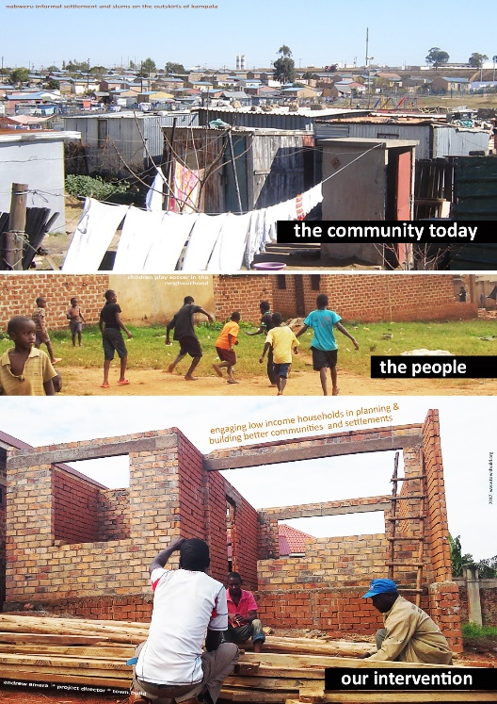
(ILLUSTRATION #9: Housing project)

MY PARTICIPATION IN THE BERKELEY PRIZE AS A STUDENT OPENED UP MY EYES TO THE HUMAN ELEMENT OF WHAT ARCHITECTS DO: WE ARE SUPPOSED TO TOUCH LIVES, AND TRANSFORM LIVES BY IMPROVING ACCESS TO QUALITY SPACES AND SHELTER. IT ALSO SHOWED ME THAT PARTICIPATION FROM LOCAL COMMUNITIES YIELDS BETTER RESULTS IN DESIGN…

I NOW RUN AN URBAN DEVELOPMENT PROGRAM WHERE WE ENGAGE LOW INCOME HOUSEHOLDS IN IMPROVING ACCESS TO SUSTAINABLE HOUSING. I ALSO LEAD AN ARCHITECTURE PRACTICE WHERE WE EXPLORE INNOVATIONS IN VARIOUS AWARD-WINNING PROJECTS ACROSS THE COUNTRY. AS A BERKELEY PRIZE COMMITTEE MEMBER, UNIVERSITY INSTRUCTOR AND ALUMNI LEADER, I CONTINUE TO MENTOR STUDENTS ON CAREER AND THE IMPORTANCE OF FINDING WAYS TO IMPACT SOCIETY.

NICOLE GRAYCAR, UNITED STATES, TRAVEL FELLOW, 2008. (NICOLE IS SIMILARLY NOW A BERKELEY PRIZE COMMITTEE MEMBER)

NICOLE GRAYCAR, A LICENSED ARCHITECT, CONTINUES HER WORK AS, NOW, SENIOR PROJECT MANAGER FOR CARNEGIE MELLON UNIVERSITY OF PITTSBURG, PENNSYLVANIA. REGARDING HER CONTINUING CURRENT PROJECT, SHE WRITES:

I AM HELPING CARNEGIE MELLON BECOME THE FIRST ANCHOR TENANT IN THE LARGEST UNDEVELOPED SITE WITHIN CITY LIMITS. THE RIVERFRONT PROPERTY, ONCE HOME TO STEEL MILLS AND CURRENTLY SURROUNDED BY A DEPRESSED COMMUNITY, WILL BE AT THE FOREFRONT OF SUSTAINABILITY AND COMMUNITY ENGAGEMENT.

THIS IS AN EXAMPLE OF HOW, EVEN WORKING WITHIN A LARGE ORGANIZATION WITH ANY NUMBER OF PRESSING ISSUES AND THE DAY-TO-DAY REQUIREMENTS OF A MASSIVE BUILDING PROJECT, THE LESSONS OF THE SOCIAL ART OF ARCHITECTURE CAN BE APPLIED.

SOPHIA BANNERT, UNITED KINGDOM, 1ST PLACE, 2013 ESSAY COMPETITION.

THE ACCESSIBILITY PROBLEMS I DISCOVERED WHILST RESEARCHING FOR THE WINNING ESSAY HAVE STUCK WITH ME EVER SINCE. I FEEL STRONGLY THAT THESE PROBLEMS CAN BE ERADICATED WITH A LITTLE EFFORT. IN 2014 I WON THE ARCHITECTS JOURNAL WRITING PRIZE FOR AN ESSAY DISCUSSING THE EXPERIENCE OF ARCHITECTURE WITHOUT SIGHT – SOMETHING I WAS SENSITIVE TO AFTER TAKING PART IN THE BERKELEY PRIZE…ALL OF MY PROJECTS (ARE) NOW DEEPLY AWARE OF THE IMPORTANCE OF THE SOCIAL ART OF ARCHITECTURE.

SOPHIA IS CURRENTLY DEVELOPING A PROTOTYPE MAP-BASED APP CALLED BEE-ABLE, FOR WHICH SHE PREVIOUSLY WON A BRITISH ROYAL SOCIETY OF ARCHITECTS STUDENT DESIGN AWARD, THAT ALLOWS USERS TO RATE AND REVIEW THEIR CITY’S ACCESSIBILITY. IT ALSO ALLOWS THEM TO FIND OUT WHICH ARE THE MOST ACCESSIBLE BUSINESSES AND BOOK AHEAD, WITH CONFIDENCE, THROUGH THE USE OF ‘SCORES’ ON THE DOORS OF TOP-RATED PLACES AND VENUES. FOR THOSE BUSINESSES WITH LOW SCORES, BEE-ABLE WILL ALSO OFFER BESPOKE ARCHITECTURAL, PLANNING AND PROJECT MANAGEMENT APPS TO ADDRESS ANY ACCESSIBILITY ISSUES HIGHLIGHTED BY APP USERS.

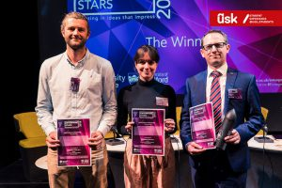
(ILLUSTRATION #10: BRSA awards ceremony)

FAIQ MARI, OCCUPIED PALESTINIAN TERRITORY, 2ND PLACE, 2013 ESSAY COMPETITION

FAIQ IS AN ARCHITECT WORKING IN THE FIELD OF ARCHITECTURAL DESIGN, RESEARCH, AND EDUCATION WITH A FOCUS ON ARCHITECTURE’S POTENTIAL AS A TOOL FOR SOCIAL AND POLITICAL INVESTIGATION AND ACTION. HE HAS TAUGHT AT BIRZEIT UNIVERSITY AND PRACTICES ARCHITECTURE IN PALESTINE. AT BIRZEIT, HE FOCUSED ON DEVELOPING UNIVERSAL DESIGN EDUCATION AT THE DEPARTMENT OF ARCHITECTURE, AND LED APPLIED RESEARCH ON DEVELOPING LOCALIZED BUILDING TECHNIQUES IN THE OCCUPIED JORDAN VALLEY OF PALESTINE.

FAIQ RECENTLY FINISHED A MASTERS DEGREE IN ARCHITECTURE HISTORY AND THEORY FROM THE UNIVERSITY OF MICHIGAN, ANN ARBOR, WHERE HE WAS A FULBRIGHT SCHOLAR. HIS THESIS INVESTIGATED THE RELATIONSHIP BETWEEN ZIONIST COLONIAL INFRASTRUCTURE EXPANSION AND PALESTINIAN RESISTANCE IN THE WEST BANK, FROM AN ARCHITECTURAL STANDPOINT. HE IS NOW FOLLOWING THIS UP AS A DOCTORAL FELLOW AT THE INSTITUTE FOR THE HISTORY AND THEORY OF ARCHITECTURE (GTA) AT ETH ZÜRICH. HE IS ALSO AN EDITOR AT ARAB URBANISM, AN ONLINE ZINE.

HIS IS AN EXAMPLE OF MERGING THE SOCIAL ART OF ARCHITECTURE WITH POLITICAL ACTION.

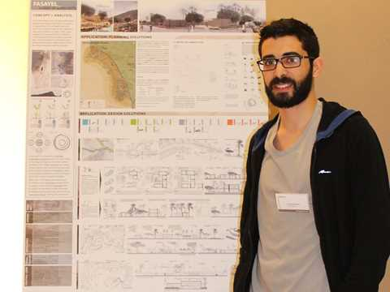
(ILLUSTRATION #11: Master’s degree presentation)

APARNA RAMESH, INDIA, 3RD PLACE, 2014 ESSAY COMPETITION

AFTER MY GRADUATION IN MAY 2015, I HEADED OFF TO BANGALORE (WHERE) I HAD THE OPPORTUNITY TO MEET THE YOUNG AND ENTHUSIASTIC TEAM OF GUARDIANS OF DREAMS, A CITY NGO WORKING PASSIONATELY TO IMPROVE THE LIFE OUTCOMES OF YOUNG ORPHANS AND STREET CHILDREN. AT THAT TIME, THEIR FOCUS WAS ON RENOVATING SEVERAL SCHOOLS AND SHELTER HOMES ACROSS BANGALORE AND WERE ON THE LOOKOUT FOR DESIGNERS TO COLLABORATE WITH….FOR DIRECTION AND INSPIRATION, I FREQUENTLY REVISITED THE FIELD NOTES AND RESEARCH FOR MY BERKELEY PRIZE ESSAY, ‘THE ARCHITECTURE OF A HEALTHFUL LEARNING ENVIRONMENT’.

APARNA WAS ONE OF FIVE CEPT UNIVERSITY GRADUATES WHO WERE SELECTED FOR A ONE-YEAR FELLOWSHIP WITH THE INDIA SMART CITIES FELLOWSHIP PROGRAM 2020. LAUNCHED BY MINISTRY OF HOUSING AND URBAN AFFAIRS (MOHUA), THE PROGRAM “GIVES YOUNG PROFESSIONALS AN OPPORTUNITY TO PROVIDE CREATIVE SOLUTIONS TO PRESSING CHALLENGES IN URBAN INDIA.

DELMA PALMA, UNITED STATES, 2014 TRAVEL FELLOWSHIP

AFTER HER FELLOWSHIP AND GRADUATION MS. PALMA WAS HIRED AS AN ARCHITECT AND URBAN DESIGNER FOR THE FIRM OF TORTI GALLAS + PARTNERS, “ARCHITECTS OF A BETTER WORLD,” HEADQUARTERED IN SILVER SPRINGS, MARYLAND, USA. HER INITIAL RESPONSE WAS WRITTEN WHILE SHE WAS WORKING WITH THE FIRM. IMAGINE HANDING YOUR BUSINESS CARD TO A CLIENT WITH THE WORDS, “ARCHITECTS OF A BETTER WORLD!” THAT IS MARVELOUS.

I AM AN ARCHITECT AND URBAN DESIGNER (IN A FIRM WHICH) DESIGNS MIXED-INCOME COMMUNITIES IN SOME OF THE MOST IMPOVERISHED AREAS OF THE UNITED STATES…MY CO-WORKERS AND I WORK WITH MANY ENTITIES, SUCH AS CITY HOUSING AUTHORITIES, PUBLIC PLANNING DEPARTMENTS AND PRIVATE DEVELOPERS TO DE-CONCENTRATE THE POVERTY THAT WAS EXACERBATED BY THE WAY PUBLIC HOUSING WAS DEVELOPED IN THE 1950S AND ‘60S. THROUGH DESIGNING MIXED-INCOME COMMUNITIES WE HELP CITIES AND NEIGHBORHOODS BECOME MORE RESILIENT SOCIALLY, ECONOMICALLY, AND PHYSICALLY.

DELMA IS NOW A COMMUNITY DESIGN ARCHITECT FOR THE CAPITAL PROJECTS DIVISION OF THE NEW YORK CITY HOUSING AUTHORITY (NYCHA), WHERE SHE RECENTLY LED THE CONNECTED COMMUNITIES INITIATIVE AS AN URBAN DESIGN FELLOW. THE INITIATIVE IS A PROGRAM “TO INTEGRATE OVER 350 PUBLIC HOUSING DEVELOPMENTS BETTER INTO THE FABRIC OF NEW YORK CITY. THROUGH URBAN DESIGN, RESIDENT ENGAGEMENT AND PUBLIC-PRIVATE PARTNERSHIPS, NYCHA IS PROMOTING MORE INCLUSIVE AND CONNECTED DEVELOPMENTS SO THAT RESIDENTS CAN TAKE ADVANTAGE OF THE MANY RESOURCES NEW YORK HAS TO OFFER.” IN OTHER WORDS, EVEN THOUGH DELMA IS WORKING WITHIN A LARGE GOVERNMENT AGENCY, SHE IS COMMITTED TO ACHIEVE SOMETHING THAT ADDDRESSES THE SOCIAL ART OF ARCHITECTURE.

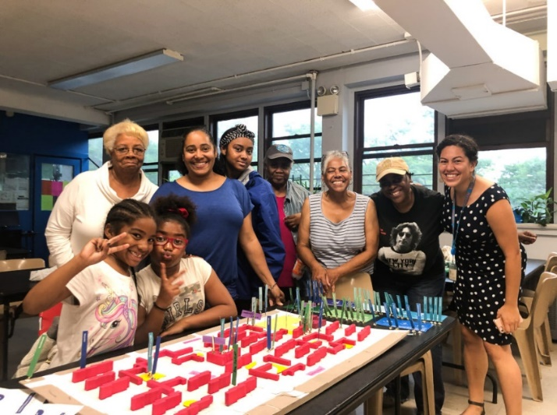
(ILLUSTRATION #12: NYCHA Workshop)

A NAME THAT MIGHT BE FAMILIAR TO YOU: SPA BHOPAL’S NIPUN PRABHAKAR, WHO WITH SUKRUTI GUPTA, WON OUR 2ND PLACE, 2014 ESSAY COMPETITION. THEIR ESSAY WAS ENTITLED, "SPACES TO GROW: A COMPARATIVE STUDY OF TWO ORPHANAGES." NIPUN RESPONDED TO US:

I DID MY INTERNSHIP IN A GRASSROOTS ORGANISATION, HUNNARSHALA. THERE, I WORKED IN A POST-RIOT REHABILITATION PROJECT IN MUZAFFARNAGAR WITH THE PEOPLE WHO WERE INTERNALLY DISPLACED. WE WERE HELPING THEM BUILD THEIR HOUSES. I TOOK THE SAME TOPIC FOR MY THESIS AND CAME OUT WITH A FRAMEWORK BASED ON ARCHITECTURAL INTERPRETATIONS OF GANDHI’S IDEAS LINKED WITH CHRISTOPHER ALEXANDER'S PATTERN LANGUAGE, TRANSLATED INTO THE DESIGN OF HOUSES FOR THE PROJECT. THE THESIS/GRADUATION PROJECT WON RECOGNITION AND AWARDS AROUND THE WORLD.

AFTER GRADUATING, I WENT ON TO EXPLORE SOCIAL ACTIVISM AND THROUGH A SCHOLARSHIP AND JOINED A SOCIAL MOVEMENT FOR THE RIGHT TO ACCOUNTABILITY IN INDIA. IN JANUARY 2017, I STARTED WORKING IN NEPAL AS A CONSULTANT ARCHITECT FOR HUNNARSHALA. WE WORKED WITH THE TIBETAN REFUGEE NUNS, RE-BUILDING THEIR MEDITATION HOUSES WHICH FELL DURING THE EARTHQUAKE OF 2015.

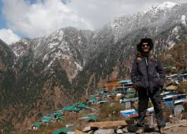
(ILLUSTRATION #13: HUNNARSHALA Project)

AFTER THE PROJECT WAS FINISHED, I WAS INVITED TO WORK IN KATHMANDU ON POST-EARTHQUAKE REHABILITATION WHERE HUNNARSHALA IS WORKING WITH ANOTHER LOCAL ORGANISATION, LUMANTI. I ALSO HAVE A STRONG INTEREST IN PHOTOJOURNALISM. AS A RESULT, I AM ALSO PROFESSIONALLY DOCUMENTING BUILDINGS AND SOCIAL ARCHITECTURE PROJECTS.

NIPUN IS NOW ALSO THE SOUTH ASIA COORDINATOR FOR THE TAMAYOUZ EXCELLENCE AWARDS, ONE OF THE MOST RECOGNIZED ARCHITECTURE AWARDS IN THE MIDDLE EAST. THIS PRIZE WAS “ESTABLISHED IN 2012 BY IRAQI ARCHITECT AND COVENTRY UNIVERSITY ACADEMIC AHMED AL-MALLAK AND IS THE FIRST ARCHITECTURE AWARDS PROGRAMME TO EMERGE FROM IRAQ. IN THE SEVEN YEARS SINCE ITS LAUNCH, IT HAS GROWN BOTH EXTERNALLY AND INTERNALLY.

ANDREEA MOVILA, ROMANIA, 2015 TRAVEL FELLOWSHIP

RETURNING FROM THE TRAVEL SPONSORED BY THE PRIZE I WON, I CONVINCED THE DEAN OF MY ARCHITECTURE SCHOOL THAT A CONTEST, ADDRESSED TO STUDENTS OF ARCHITECTURE FROM ROMANIA REFERRING TO SOCIAL PROBLEMS IN THE COUNTRY WOULD BE VERY NECESSARY. HE INVITED ME TO COME WITH A PROPOSAL - REGULATION, JURY, PRIZES. AFTER A PERIOD OF HARD WORKING, SPONSORSHIPS, JURY MEMBERS, REGULATION FRAMEWORK ETC. - IN 2015 WE HAD THE FIRST EDITION OF THE CONTEST THAT WE ENTITLED "ARCHITECTURE OF ALTERITY" (I MYSELF HAD TO LOOK UP THE DEFINITION: THE ARCHITECTURE OF THE OTHER. – HOW PERFECT!) WITH A JURY COMPOSED OF WELL-KNOWN THEORISTS FROM ROMANIA.

ANDREEA IS NOW EDITOR OF SHARE-ARCHITECTURE-ROMANIA, WHERE THE “ARCHITECTURE COMMUNITY COMES TOGETHER TO SHARE IDEAS AND INSPIRATION, LEARN AND CELEBRATE EXCELLENCE IN ARCHITECTURE.”

-------------------

IT HAS LONG BEEN CLEAR THAT OBTAINING A DEGREE IN ARCHITECTURE DOES NOT ALWAYS LEAD TO A CAREER IN DESIGNING AND BUILDING PHYSICAL STRUCTURES.

STUDYING THE SOCIAL ART OF ARCHITECTURE OFTEN LEADS TO A HOST OF OTHER RELATED AND EQUALLY VALUABLE PURSUITS. THIS IS MADE ABUNDANTLY CLEAR BY SEVERAL OF OUR WINNERS’ BIOGRAPHIES. ONE PARTICULARLY STANDS OUT:

PREETI TALWAI, UNITED STATES, ARCHITECTURAL DESIGN FELLOW, 2011. (PRIZE COMMITTEE MEMBER AND 2018 PRIZE JUROR)

AFTER COMPLETING MY BACHELOR'S DEGREE IN ARCHITECTURE AT UC BERKELEY AND A MASTER OF ENVIRONMENTAL DESIGN AT THE YALE SCHOOL OF ARCHITECTURE, I AM CURRENTLY WORKING AS A USER EXPERIENCE RESEARCHER AT X (FORMERLY GOOGLE[X]), THE INNOVATION LAB OF GOOGLE. IN THIS ROLE, I CONDUCT QUALITATIVE HUMAN-CENTERED RESEARCH THAT HELPS VET FUTURISTIC IDEAS AND DETERMINE WHICH ARE WORTH PURSUING. I STUDY HUMAN NEEDS, ATTITUDES, MOTIVATIONS, AND BEHAVIORS ACROSS DIFFERENT DOMAINS AND ECOSYSTEMS.

THE CORE VALUES OF THE SOCIAL ART OF ARCHITECTURE -- HAVE BEEN CENTRAL TO MY WORK AFTER COLLEGE. MY DECISION TO PURSUE A GRADUATE ARCHITECTURAL THEORY DEGREE WAS MOTIVATED IN LARGE PART BY MY UNDERGRADUATE WRITING AND THINKING ABOUT SOCIAL ARCHITECTURE. IN TURN, MY GRADUATE THESIS CRITICALLY EXAMINED THE IMPACT THAT TECHNOLOGY HAS ON THE SOCIAL EXPERIENCE OF PUBLIC SPACE AND THE ACT OF CONSUMPTION.
-------------------

SO, FINALLY, WHAT IS THE SOCIAL ART OF ARCHITECTURE?

CERTAINLY, IT IS ALL WHAT I HAVE TALKED ABOUT TODAY AND ALL WHAT THE BERKELEY PRIZE WINNERS HAVE TALKED ABOUT. IT IS, HOPEFULLY, WHAT MY LIFE HAS BEEN ABOUT AND WILL BE ABOUT IN THE FUTURE, REGARDLESS OF THE PRESSURES AND RESTRAINTS OF THE MOMENT.

IF I HAD TO PUT THIS DEFINITION INTO ONE SENTENCE, HOWEVER, IT WOULD BE THAT:
THE SOCIAL ART OF ARCHITECTURE IS THE ACCEPTANCE OF THE FACT THAT GOOD ARCHITECTURE— AND A BETTER ARCHITECTURE—CAN ONLY START WITH A DEEP AND THOROUGH UNDERSTANDING AND INTEREST IN THE PEOPLE WHO USE AND ARE AFFECTED BY A BUILDING OR A PLACE.
LET ME REPEAT THAT:
THE SOCIAL ART OF ARCHITECTURE IS THE ACCEPTANCE OF THE FACT THAT GOOD ARCHITECTURE— AND A BETTER ARCHITECTURE—CAN ONLY START WITH A DEEP AND THOROUGH UNDERSTANDING AND INTEREST IN THE PEOPLE WHO USE AND ARE AFFECTED BY A BUILDING OR A PLACE.
IT IS STILL DIFFICULT TO BELIEVE THAT THIS SORT OF BASIC UNDERSTANDING OF THE TASK OF DESIGN IS NOT MORE WIDELY ACKNOWLEDGED OR ACCEPTED THROUGHOUT THE ARCHITECTURAL PROFESSION.
LET THE CHANGE START NOW, IN PLACES LIKE SPA BHOPAL…AND THROUGH OPPORTUNITIES LIKE THE BERKELEY PRIZE.
THANK YOU.
----------------------
A graduate of U.C. Berkeley’s College of Environmental Design, Benjamin Clavan is Principle of BENJAMIN CLAVAN ARCHITECT (Los Angeles, U.S.A. and Valencia, Spain); longtime Coordinator and website editor for the Berkeley Prize, and a member of the Prize Committee. In different periods of his professional life he has also been active as an architectural journalist/writer. In addition, he has served as both an appointed and elected member of his local city planning and public facilities commissions. In all of these endeavors, his primary focus has been on making people matter in the design process.

